Noise Sources and Their Effects
Noise Source | Decibel  Level | comment
Jet take-off (at 25 meters) | 150 | Eardrum rupture
Aircraft carrier deck | 140
Military jet aircraft take-off from aircraft carrier with afterburner at 50 ft (130 dB). | 130
Thunderclap, chain saw. Oxygen torch (121 dB). | 120 | Painful. 32 times as loud as 70 dB.
Steel mill, auto horn at 1 meter. Turbo-fan aircraft at takeoff power at 200 ft (118 dB). Riveting machine (110 dB); live rock music (108 - 114 dB). | 110 | Average human pain threshold. 16 times as loud as 70 dB.
Jet take-off (at 305 meters), use of outboard motor, power lawn mower, motorcycle, farm tractor, jackhammer, garbage truck. Boeing 707 or DC-8 aircraft at one nautical mile (6080 ft) before landing (106 dB); jet flyover at 1000 feet (103 dB); Bell J-2A helicopter at 100 ft (100 dB).(This is a light helicopter)  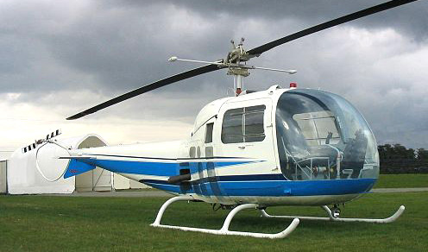 | 100 | 8 times as loud as 70 dB. Serious damage possible in 8 hr exposure
Boeing 737 or DC-9 aircraft at one nautical mile (6080 ft) before landing (97 dB); power mower (96 dB); motorcycle at 25 ft (90 dB). Newspaper press (97 dB). | 90 | 4 times as loud as 70 dB. Likely damage 8 hr exp
Garbage disposal, dishwasher, average factory, freight train (at 15 meters). Car wash at 20 ft (89 dB); propeller plane flyover at 1000 ft (88 dB); diesel truck 40 mph at 50 ft (84 dB); diesel train at 45 mph at 100 ft (83 dB). Food blender (88 dB); milling machine (85 dB); garbage disposal (80 dB). | 80 | 2 times as loud as 70 dB. Possible damage in 8 h exposure.
Passenger car at 65 mph at 25 ft (77 dB); freeway at 50 ft from pavement edge 10 a.m. (76 dB). Living room music (76 dB); radio or TV-audio, vacuum cleaner (70 dB). | 70 | Arbitrary base of comparison. Upper 70s are annoyingly loud to some people.
Conversation in restaurant, office, background music, Air conditioning unit at 100 ft | 60 | Half as loud as 70 dB. Fairly quiet
Quiet suburb, conversation at home. Large electrical transformers at 100 ft | 50 | One-fourth as loud as 70 dB.
Library, bird calls (44 dB); lowest limit of urban ambient sound | 40 | One-eighth as loud as 70 dB.
Quiet rural area | 30 | One-sixteenth as loud as 70 dB. Very Quiet
Whisper, rustling leaves | 20
Breathing | 10 | Barely audible

